OOP Lab 13
13.1 By using the above menu code, by add a text box in it and make a notepad make it functional.
Source code
import tkinter
import os
from tkinter import *
from tkinter.messagebox import *
from tkinter.filedialog import *

class Notepad:

__root = Tk()

# default window width and height
__thisWidth = 300
__thisHeight = 300
__thisTextArea = Text(__root)
__thisMenuBar = Menu(__root)
__thisFileMenu = Menu(__thisMenuBar, tearoff=0)
__thisEditMenu = Menu(__thisMenuBar, tearoff=0)
__thisHelpMenu = Menu(__thisMenuBar, tearoff=0)

# To add scrollbar
__thisScrollBar = Scrollbar(__thisTextArea)
__file = None

def __init__(self,**kwargs):

# Set icon
try:
self.__root.wm_iconbitmap("Notepad.ico")
except:
pass

# Set window size (the default is 300x300)

try:
self.__thisWidth = kwargs['width']
except KeyError:
pass

try:
self.__thisHeight = kwargs['height']
except KeyError:
pass

# Set the window text
self.__root.title("Untitled - Notepad")

# Center the window
screenWidth = self.__root.winfo_screenwidth()
screenHeight = self.__root.winfo_screenheight()

# For left-alling
left = (screenWidth / 2) - (self.__thisWidth / 2)

# For right-allign
top = (screenHeight / 2) - (self.__thisHeight /2)

# For top and bottom
self.__root.geometry('%dx%d+%d+%d' % (self.__thisWidth,
self.__thisHeight,
left, top))

# To make the textarea auto resizable
self.__root.grid_rowconfigure(0, weight=1)
self.__root.grid_columnconfigure(0, weight=1)

# Add controls (widget)
self.__thisTextArea.grid(sticky = N + E + S + W)

# To open new file
self.__thisFileMenu.add_command(label="New",
command=self.__newFile)

# To open a already existing file
self.__thisFileMenu.add_command(label="Open",
command=self.__openFile)

# To save current file
self.__thisFileMenu.add_command(label="Save",
command=self.__saveFile)

# To create a line in the dialog
self.__thisFileMenu.add_separator()
self.__thisFileMenu.add_command(label="Exit",
command=self.__quitApplication)
self.__thisMenuBar.add_cascade(label="File",
menu=self.__thisFileMenu)

# To give a feature of cut
self.__thisEditMenu.add_command(label="Cut",
command=self.__cut)

# to give a feature of copy
self.__thisEditMenu.add_command(label="Copy",
command=self.__copy)

# To give a feature of paste
self.__thisEditMenu.add_command(label="Paste",
command=self.__paste)

# To give a feature of editing
self.__thisMenuBar.add_cascade(label="Edit",
menu=self.__thisEditMenu)

# To create a feature of description of the notepad
self.__thisHelpMenu.add_command(label="About Notepad",
command=self.__showAbout)
self.__thisMenuBar.add_cascade(label="Help",
menu=self.__thisHelpMenu)

self.__root.config(menu=self.__thisMenuBar)

self.__thisScrollBar.pack(side=RIGHT,fill=Y)

# Scrollbar will adjust automatically according to the content
self.__thisScrollBar.config(command=self.__thisTextArea.yview)
self.__thisTextArea.config(yscrollcommand=self.__thisScrollBar.set)

def __quitApplication(self):
self.__root.destroy()
# exit()

def __showAbout(self):
showinfo("Notepad","Mrinal Verma")

def __openFile(self):

self.__file = askopenfilename(defaultextension=".txt",
filetypes=[("All Files","*.*"),
("Text Documents","*.txt")])

if self.__file == "":

# no file to open
self.__file = None
else:

# Try to open the file
# set the window title
self.__root.title(os.path.basename(self.__file) + " - Notepad")
self.__thisTextArea.delete(1.0,END)

file = open(self.__file,"r")

self.__thisTextArea.insert(1.0,file.read())

file.close()

def __newFile(self):
self.__root.title("Untitled - Notepad")
self.__file = None
self.__thisTextArea.delete(1.0,END)

def __saveFile(self):

if self.__file == None:
# Save as new file
self.__file = asksaveasfilename(initialfile='Untitled.txt',
defaultextension=".txt",
filetypes=[("All Files","*.*"),
("Text Documents","*.txt")])

if self.__file == "":
self.__file = None
else:

# Try to save the file
file = open(self.__file,"w")
file.write(self.__thisTextArea.get(1.0,END))
file.close()

# Change the window title
self.__root.title(os.path.basename(self.__file) + " - Notepad")

else:
file = open(self.__file,"w")
file.write(self.__thisTextArea.get(1.0,END))
file.close()

def __cut(self):
self.__thisTextArea.event_generate("<<Cut>>")

def __copy(self):
self.__thisTextArea.event_generate("<<Copy>>")

def __paste(self):
self.__thisTextArea.event_generate("<<Paste>>")

def run(self):

# Run main application
self.__root.mainloop()

# Run main application
notepad = Notepad(width=600,height=400)
notepad.run()

Output
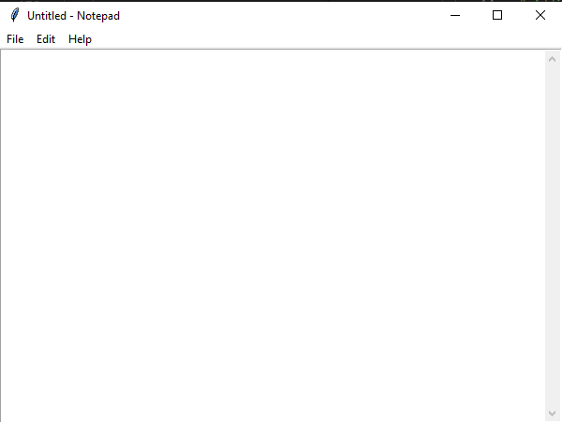

13.2 By using the progress bar code, open a new window by completing progress bar.
Source code
from tkinter import *
from tkinter import ttk
from time import sleep
import tkinter as tk

class App(tk.Tk):
def __init__(self, *args, **kwargs):
tk.Tk.__init__(self, *args, **kwargs)
self.button = ttk.Button(text="Generate Invoice", command=self.start)
self.button.pack()
self.labelText = tk.StringVar()
self.genLabel = ttk.Label(textvariable=self.labelText)
self.labelText.set(" ")
self.genLabel.pack()
self.progress = ttk.Progressbar(self, orient="horizontal",length=150, mode="determinate")
self.progress.pack()
self.pr = 0
self.prmax = 0

def increase(self):
self.pr += 5
self.progress["value"] = self.pr
if self.pr < self.prmax:
self.after(100, self.increase)

def start(self):
self.progress["value"] = self.pr
self.prmax = 100
self.progress["maximum"] = self.prmax
self.labelText.set("Generating Invoice")
self.increase()

Nabeel = App()
Nabeel.mainloop()

Output
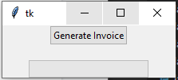
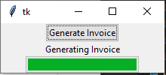

13.2 By using the progress bar code, show the percentage on progress bar.
Source code
import tkinter as tk
from tkinter import ttk

Nabeel = tk.Tk()

style = ttk.Style(Nabeel)
# add label in the layout
style.layout('text.Horizontal.TProgressbar',
[('Horizontal.Progressbar.trough',
{'children': [('Horizontal.Progressbar.pbar',
{'side': 'left', 'sticky': 'ns'})],
'sticky': 'nswe'}),
('Horizontal.Progressbar.label', {'sticky': ''})])
# set initial text
style.configure('text.Horizontal.TProgressbar', text='0 %')
# create progressbar
variable = tk.DoubleVar(Nabeel)
pbar = ttk.Progressbar(Nabeel, style='text.Horizontal.TProgressbar', variable=variable)
pbar.pack()

def increment():
pbar.step() # increment progressbar
style.configure('text.Horizontal.TProgressbar',
text='{:g} %'.format(variable.get())) # update label
Nabeel.after(200, increment)

increment()

Nabeel.mainloop()

Output
